A Resident’s Guide to Precepting via Telemedicine

Set-Up
- For now, only attendings have a Telemedicine schedule, so you’ll find your patients for the day on your preceptor’s schedule on eCW
  - You can either look for them on the Resource Schedule
  - Or you can find them on the Office Visit Screen if you change your “facility” to the “Telemedicine” version of your site, for example “Telemedicine CHA – Anacostia” (second page of eCW facility options)
- You should take a look at the patient’s problem list, medication list, and recent encounters as you would prior to seeing any other clinic patient
- Patients should have already been consented for Telehealth by a PCT prior to the appointment.
  - This consent should already be documented in the note
  - If consent is not documented, you or your preceptor will have to obtain and document this consent at the beginning of the visit. Please merge the “telemedicine- English” or “telemedicine- Spanish” template and read the language.
- Patients will have a link to your preceptor’s virtual waiting room, where they will start the visit
- Your preceptor should send you a link to their virtual waiting room prior to a clinic session

Different Models of Precepting- Your preceptor will discuss which precepting model will be used

Direct Observation
- You, the patient and the attending will all be in the room together
- Depending on the patient- either the attending will run the visit and you will observe OR you will run the visit and the attending will observe
- Decide who will be doing ECW documentation before the patient enters
- When you are running the visit- if you would like to discuss the case prior to discussing plans with family- Please tell the family: “You will be back in the waiting room for just a couple minutes while we discuss the case”, then the attending will move the family back to the waiting room

Indirect Observation with precepting before patient leaves (Breakout rooms)
- This similar to how we precept in person- you will see the patient and then discuss with attending. The attending may come see that patient, confirm physical exam findings such as rash etc.
- Your preceptor should make you a co-host of the meeting on Zoom, so that you may move around the breakout rooms
- Your preceptor will place you in your own breakout room where you will wait for your patient
- Your preceptor will greet the patient / family member in the “main meeting” window, then place the patient / family in your breakout room, where the encounter will take place
- You will know your patient is ready for the visit when they appear in your breakout room with you.

The Physical Exam
- The following elements of the physical exam are appropriate to perform and document, if appropriate to the chief complaint, using Telemedicine:
  - General appearance “alert, well-hydrated, no acute distress”
  - HEENT: “no conjunctival injection seen on video and no eyelid swelling, EOMI, no nasal discharge noted”
  - Oral cavity: “moist mucous membranes”
  - Neck: “full range of motion”
  - Lungs: “no signs of respiratory distress, speaking in full sentences, able to take a deep breath easily”
  - Abdomen: “no tenderness evident on video when palpated by parent”
  - Skin: descriptions of rash characteristics
  - Extremities: “no tenderness evident on video when palpated by parent, full range of motion, no swelling evident on video”
  - Neuro: “normal gait evident on video”

Precepting / Concluding (If breakout rooms are being used)
- If you would like to precept prior to dismissing the patient:
  - Explain to the family you will be right back after speaking with your preceptor
  - Click the “Breakout Rooms” button by rolling your cursor to bring up the options bar
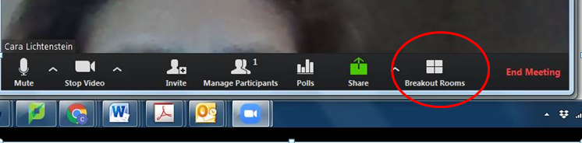
This will bring up a list of the breakout rooms. From there click “join” on the right side of “Precepting Room” where you will meet with your attending to discuss the patient.
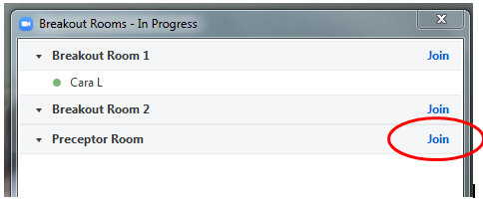
  - You can use this same process to go back to your patient breakout room
  - Your attending may then join you in your breakout room after precepting if desired
- In order to end the encounter, you must ask the patient / family member to “leave” the Zoom meeting
  - They may have to tap their screen in order for the “Leave Meeting” option to appear

Documentation
- eCW does not minimize well on the computer screen, and for that reason it is difficult to document in eCW during a Zoom encounter if you are using only one computer for both purposes
  - You may want to type notes during the encounter in an easier documentation program such as Notepad, Word, or Sticky Notes, then add them to eCW later
- Some part of the note must include the rationale for a Telehealth visit as opposed to an in-person clinic visit as well as the state/territory where the patient is located during the visit (which may be different from their home address). The suggested language is:
  - The patient/family stated they are located in Washington, DC during their telemedicine visit. This visit was conducted via telemedicine given the risks associated with seeing the patient/family in person during the COVID-19 crisis.
- Add your name / PGY year to the note via the following in eCW: HPI Student Resident
  - You may also document your HPI in the “Resident HPI” section here if you’d like, or use the “HPI General” section.
- Otherwise, you may proceed with the note as usual. You will not need to “assign” the note to your preceptor, since it is already on their schedule.
- Make sure that you verify the patient’s medication list and allergies

Prescriptions
- Since the encounter is on your preceptor’s schedule, you will not be able to send any prescriptions to the pharmacy. However, you should still pend prescriptions to be sent so that your preceptor may send them as they review the note.
- Be sure to document the preferred pharmacy in the note or “stickies” section so your preceptor knows where to send the prescription

