Children’s National Medical Center Pediatric Residency Program
TEACHING ELECTIVE
Dr. Aisha Davis, abdavis@childrensnational.org, vm202-476-6958, p202-259-8126

Goals
This rotation aims to increase resident exposure to the background of education and adult learning theory and allow for exploration and practice of techniques employed to teach in clinical settings with opportunities for critique, deliberate practice, experimentation, feedback, and reflection.
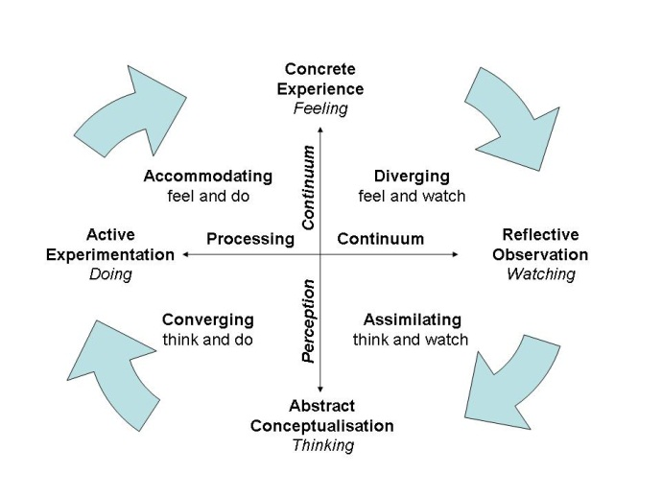
Needs
Throughout residency, residents gain exposure to many practical opportunities to teach. However, there is infrequently dedicated time for other activities that will improve their practice as educators.
1 Kolb Learning Cycle
Learning Objectives
Based on the length of the elective, 3 to 5 of the following learning objectives will be addressed. The focus will be selected by the participant.

After completing associated modules of this elective, residents will be able to:
- Describe adult learning theory in relation to clinical medical education
- Plan and lead small group learning events tailored to qualities of adult learners in clinical settings
- Utilize strategies to teach clinical reasoning during clinical encounters
- Prompt learners to set goals and reflect during orientation, feedback, and other opportunities to enhance a learner’s educational experience.
- Facilitate learning during a simulated scenario
Methods
Depending upon the duration of elective and learning goals of participant, the following methods may be employed.

√ | Learning Objective | Activities
 | Describe adult learning theory in relation to clinical medical education. | - Reading list & reflection questions  - Discussion w/ preceptor
 | Plan and lead small group learning events tailored to qualities of adult learners in clinical settings. | - Reading list  - Learning event critique  - Discussion w/ preceptor  - Plan & present a didactic learning event (using provided tool)  - Create your own feedback tool (mentor)  - Reflection & feedback
 | Utilize strategies to teach clinical reasoning during clinical encounters. | - Reading list  - Reflection questions  - Create your own feedback tool (mentor)  - Rounds observation, critique, & discussion  - Facilitate mini-rounds  - Reflection & feedback
 | Prompt learners to set goals and reflect during orientation, feedback, and other opportunities to enhance a learner’s educational experience. | - Reading list  - Observe Monday orientation & critique  - Observe Friday feedback & critique  - Review written evaluations & critique (examples & your own received and sent)
 | Facilitate learning during a simulated scenario. | - Self-directed workshop  - Reading list  - Observe simulation session (Friday) & critique  - Create your own feedback tool (mentor)  - Facilitate simulation session*

Sample Schedule
Please use the following to create your own calendar. Discuss with mentor on day #2 of elective.
WEEK ONE
 | Monday | Tuesday | Wednesday | Thursday | Friday
AM | Orientation  Intro to adult learning theory reading  Noon conference | Morning Report  One-on-one discussion with faculty – adult learning/ learning styles in clinical medicine  Noon conference | Grand Rounds/ Chief Sessions observation & critique  Noon conference | Morning Report observation & critique  Noon conference | Simulation observation & critique  Noon conference
PM | Literature review: adult learning theory  Reflection on learning style & teaching predilections  MS3 PE rounds | Literature review: small group & case-based learning. Complete table: principle, teacher behavior, outcome measure  MS3 PE rounds |  | Attend GW MS3 teaching session  Simulaton workshop & reading. Create observation tool. | Discussion of session critiques with faculty.  How did PE rounds change/ stay same throughout the week?
WEEK TWO
 | Monday | Tuesday | Wednesday | Thursday | Friday
AM | Rounds observation  Reading & reflection teaching & learning clinical reasoning  Noon conference | Morning Report  Rounds observation & critique using observation tool  Noon conference | Grand Rounds/ Chief Sessions  Simulation orientation, workshop, reading  Noon conference | Morning Report  Teach attending rounds (small group, case based)  Outpatient preceptor observation x 2 hours  Noon conference | Simulation observation  Noon conference
PM | Reading & reflection teaching & learning clinical reasoning  Create observation tool | Teaching clinical reasoning – case-based session w/ MS 3 group. Focus: teaching clinical reasoning | Attending rounds preparation  Simulation prep | Attending rounds feedback  Simulation session for MS3s (needs to be scheduled) | Simulation faculty feedback

Evaluation
Please submit your feedback tools, reflections, and evaluation of your teaching at the end of the elective.

Please complete plus/ delta/ comments evaluation form.

Reading List & Assignments arranged by learning objective

Pre-rotation reflection questions:
- In what previous situations have you taught?
- Who have you taught (thing beyond their role on your team)?
- What methods have you used to teach?
- What methods have you used to get your trainees interested in your subject matter?
- How do you learn best?
- Howe does your learning style impact the way you teach?
- What are your teaching strengths?
- What are your teaching weaknesses?
- What do you hope to get out of this experience?

- Describe adult learning theory in relation to clinical medical education.
Reading reflection questions:
- What’s your learning style?
- How does it influence the way you teach?
- To which learning style do you tend to teach?
- Are medical school & residency well suited for adult learners? How?
Reading list:
- Basics of adult learning (ignore video, audio useful)
- Kaufman. ABCs of teaching & learning in medicine: Applying educational theory in practice. BMJ 2003;326:213
- You Tube Video 1: Intro to Kolb1 – You Tube Reynaldo Ramirez Jr (6 minutes)
- You Tube Video 2: Intro to Kolb2 (6 minutes)
- You Tube Video 3: Introduction to Kolb – You Tube - Gonzaga (8 minutes)
- Webpage 1: IUPUI Learning Styles Intro
- Zemke, R. & Zemke, S. (1984). 30 things we know for sure about adult learning. Innovation Abstracts, 6:8, pp. 1-3.
- Argyris, C. (1991). Teaching smart people how to learn. Harvard Business Review, May/June, 99-109.

- Plan and lead small group learning events tailored to qualities of adult learners in clinical settings
Reading list:
- Writing learning objectives
- Bloom’s Taxonomy
- Small groups (skim)

Assignments:
- Learning event critique handout
- Planning a learning activity

Resources:
- Small groups in health professions education

- Utilize strategies to teach clinical reasoning during clinical encounters
Reflection questions:
- What’s your best learning experience during rounds?
- What’s your worst learning experience during rounds?
- How do you learn best during rounds?
- How do you teach during rounds?

Reading list:
- Bowen J. Educational strategies to promote clinical diagnostic reasoning. NEJM. (Purpose: what’s up with the summary statements)
- One minute preceptor chart
- Microskills of the one minute preceptor

- Prompt learners to set goals and reflect during orientation, feedback, and other opportunities to enhance a learner’s educational experience.
Reading list:
- Branch, W. & Paranjape, A. (2002). Feedback and reflection: Teaching methods for clinical settings. Academic Medicine, 77:12, 1185-1188.
- Goldman, E., Plack, M., Roche, C., Smith, J. & Turley, C. (2009). Learning in a chaotic environment. Journal of Workplace Learning, 21:7, 555-574.
- The role of teacher as mentor
- Teaching smart people to learn

- Facilitate learning during a simulated scenario

Reading list:
- Simulation Facilitator Workshop (with mentor or self directed)
- Review The Office’s Fire Drill. What principles of sound simulation practice were violated?
- Rudolph. There’s no such thing as “nonjudgemental” debriefing. 2006 Simulation in Healthcare

Resource
- Intern orientation scenario

