WET WRAPS:

How to do Wet Wraps:
Supplies:

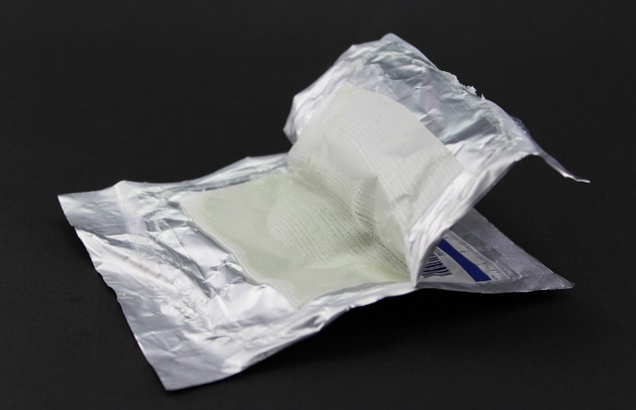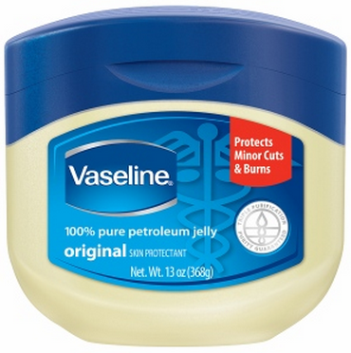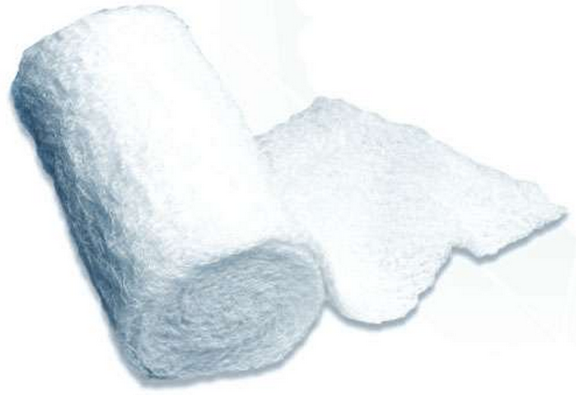
Step 1: Take a bath with plain water, and use a soap free cleanser such as __________________________________ sparingly.

Step 2 (optional): Apply _________________________________ to damp skin immediately after patting dry.

Step 3: Apply a thick layer of Vaseline (petroleum jelly) to the entire body.

Step 4: Butter the Vaseline gauze with more vaseline (petroleum jelly).

Step 5: Apply the buttered Vaseline gauze to the skin by wrapping it around the affected body part.

Step 6: Apply the kerlix/conform (rolled gauze) over the Vaseline gauze to hold it in place.

Step 7: Cut a strip in the end of the gauze after cutting it and tie it around the arm/leg.

