How to perform and order common dermatology tests: Outpatient/ED
- Bacterial culture:
  - Use an e-swab; pre-moisten swab with water prior to swabbing the skin
  - If swabbing perianal skin and looking for staph/strep, write “staph/strep” in the miscellaneous section so the lab knows to use gram-positive culture medium
  - For staph scalded skin, swab nares, umbilicus, and perianal skin (OK to use one swab for this collection if you do it in this order)
  - For “future order Y/N”, choose “no”
- Dermatophyte fungal culture: for tinea capitis or corporis
  - Use an e-swab; pre-moisten with water prior to swabbing skin
  - Swab site (if scalp, swab all 4 quadrants, affected areas last)
  - Order as “Fungal culture” and write in MC0002 in “specimen additional information”
    - If you want the lab to speciate, do not write this code
  - For “future order Y/N”, choose “no”
- HSV PCR: this is preferred to a viral culture, which takes longer and is less sensitive/specific
  - Use viral culture medium (pink liquid)
  - Unroof a blister with an 18 gauge needle and swab site
  - Order as HSV PCR, choose site “skin,” for future order, write “no”
  - In the box labeled “Specimen Additional Information” type in 10868M
- VZV PCR: this is preferred to a viral culture, which takes longer and is less sensitive/specific
  - Use viral culture medium (pink liquid)
  - Unroof a blister with an 18 gauge needle and swab site
  - Order as VZV PCR Qualitative, choose site “skin,” for future order, write “no”
  - In the box labeled “Specimen Additional Information” type in 10975M
- Mycoplasma PCR:
  - Use viral culture medium (pink liquid)
  - Perform nasopharyngeal swab
  - Order “Mycoplasma pneumoniae DNA, PCR”
  - For *Source choose “Nasopharynx”
  - In the box labeled “Specimen Additional Information” type in XOOO33
- Enteroviral PCR: for coxsackieviruses
  - Use viral culture medium (pink liquid)
  - Unroof a blister with an 18 gauge needle and swab site
  - Order “Enterovirus Qualitative PCR”
  - For *Source choose “Nasopharynx” (even if you did not swab the nasopharynx)
  - In the box labeled “Specimen Additional Information” type in X00227

E-Swab Viral Culture Medium
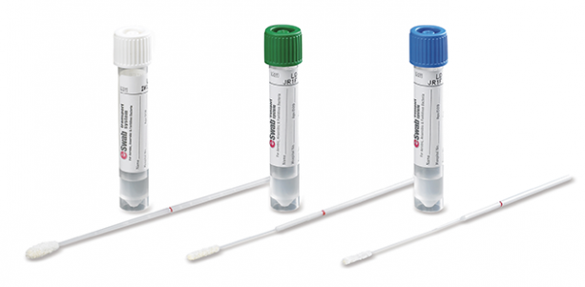

For any questions, page dermatology at 202-259-4640

How to perform and order common dermatology tests: Inpatient
- Bacterial culture:
  - Use an e-swab; pre-moisten swab with water prior to swabbing the skin
  - If swabbing perianal skin and looking for staph/strep, write “staph/strep” in the miscellaneous section so the lab knows to use gram-positive culture medium
  - For staph scalded skin, swab nares, umbilicus, and perianal skin (OK to use one swab for this collection if you do it in this order)
- HSV PCR: this is preferred to a viral culture, which takes longer and is less sensitive/specific
  - Use viral culture medium (pink liquid)
  - Unroof a blister with an 18 gauge needle and swab site
  - Order as HSV PCR, choose site “skin”
  - In the box labeled “Specimen Additional Information” type in 10868M
  - For “clinician collect” choose “yes”; for “collected Y/N” choose “yes” (see Appendix A)
- VZV PCR: this is preferred to a viral culture, which takes longer and is less sensitive/specific
  - Use viral culture medium (pink liquid)
  - Unroof a blister with an 18 gauge needle and swab site
  - Order as VZV PCR Qualitative, choose site “skin”
  - In the box labeled “Specimen Additional Information” type in 10975M
  - For “clinician collect” choose “yes”; for “collected Y/N” choose “yes” (see Appendix B)
- Mycoplasma PCR:
  - Use viral culture medium (pink liquid)
  - Perform nasopharyngeal swab (nurse)
  - Order “Mycoplasma pneumoniae DNA, PCR”
  - For *Source choose “Nasopharynx” (even if you did not swab the nasopharynx)
  - In the box labeled “Specimen Additional Information” type in XOOO33
  - For “clinician collect” choose “no”; for “collected Y/N” choose “no” (see Appendix C)
- Enteroviral PCR: for coxsackieviruses
  - Use viral culture medium (pink liquid)
  - Unroof a blister with an 18 gauge needle and swab site
  - Order “Enterovirus Qualitative PCR”
  - For *Source choose “Nasopharynx” (even if you did not swab the nasopharynx)
  - On the tab labeled Order comments” type in X00227
  - For “clinician collect” choose “yes”; for “collected Y/N” choose “yes” (see Appendix D)
- Printing labels on the wards: The labels will print on the label printer associated with the patient’s room. Ask a nurse for assistance if you can’t find it.
- Send out lab phone number 202-476-2229, Quest Chantilly phone number: 1-800-336-3718

E-Swab Viral Culture Medium
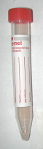

For any questions, page dermatology at 202-259-4640

Appendix A:
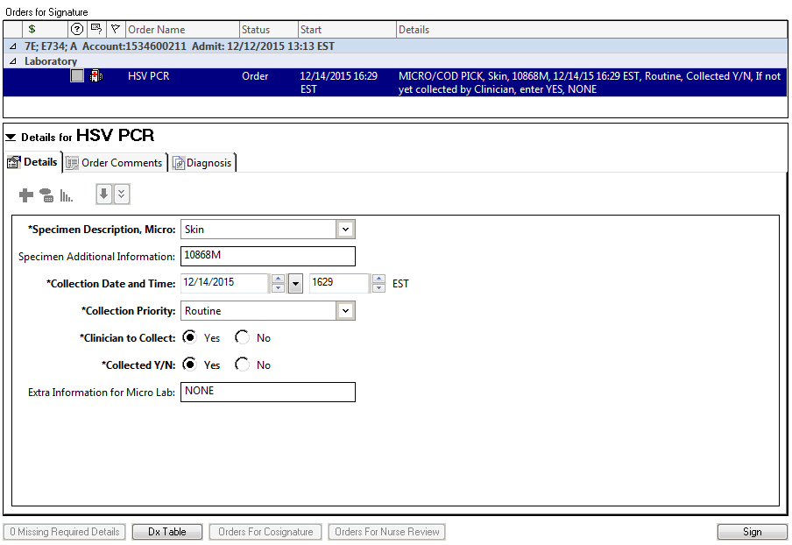
Appendix B:
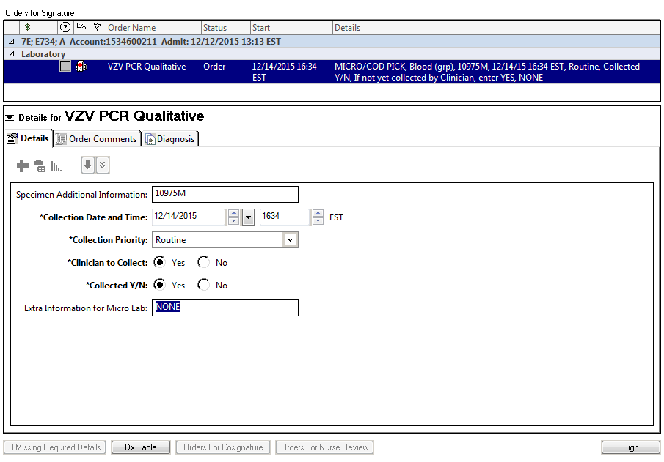
Appendix C:
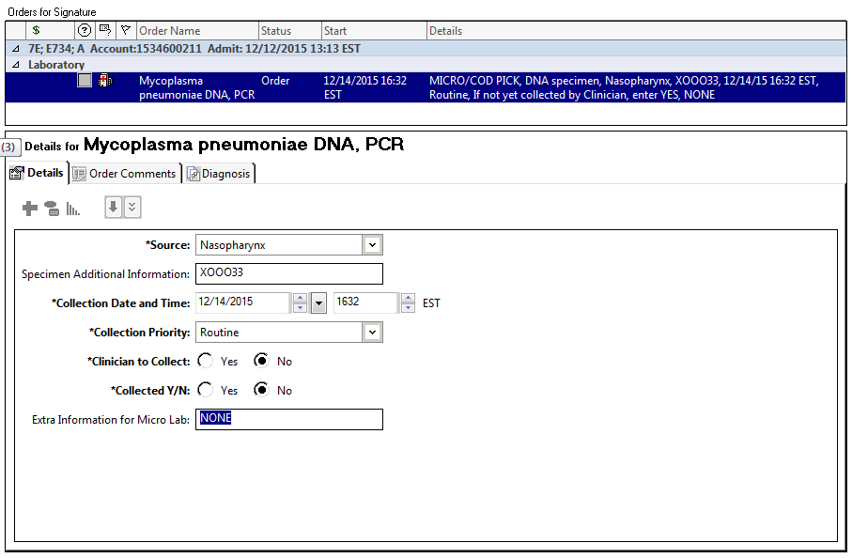
Appendix D:
