BENZOYL PEROXIDE PRODUCTS:
Use the wash in the shower to affected areas. It may bleach towels and sheets. If it causes red, itchy skin, stop using or reduce use.
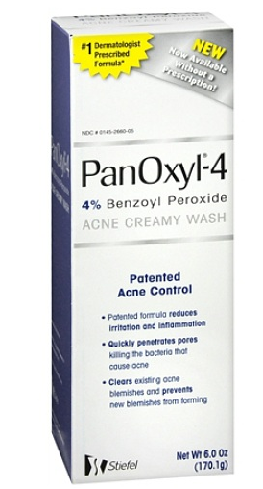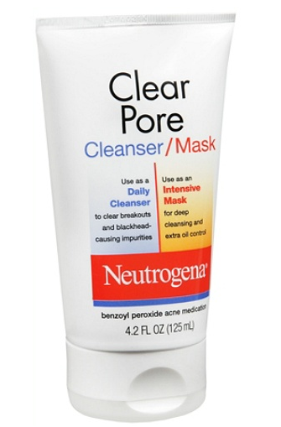

Apply this medication to red inflamed bumps and pus bumps. 