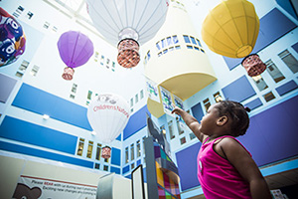
Have You Signed Up For the Asthma Scripts to School Program Yet?

What is the Asthma Scripts to Schools Program?
The program SAVES YOU TIME by delivering your child’s asthma inhalers and refills via FedEx directly to your child’s school and to your home AT NO COST! That means no need to pick inhalers up from the pharmacy, and no need to drop them off at school yourself.

What does my child need to qualify?
To qualify, your child must be:
- A student at any DC public school or a participating DC public charter school
- Must have inhaler prescriptions filled at Walgreens either at Children’s National or on Good Hope Rd
- Must have had at least 1 month since getting his/her last inhaler prescription filled.

Enrollment is as easy as 1-2-3!
- Complete the Walgreens Authorization for Medication Delivery and Refill form. Give it to your child’s healthcare provider.
- The provider will complete an Asthma Action plan for your child.
- The provider will send a prescription for your child’s asthma medications to Walgreens.

Once the forms are completed and signed by you and the provider, your child’s inhaler prescriptions will be sent to Walgreens to begin delivery. Inhalers will arrive at your child’s school (and if you choose, also to your home) in 1-3 business days.

