**Individualized Learning Plan: The Basics**

**What is an Individualized Learning Plan (ILP)?**

The ILP is a living document created by you that will allow you to actively engage in the learning process and create learning goals and activities that are relevant for you. You are expected to have one completed ILP per year of residency. The best way to create this is to summarize your learning needs based on your own self-assessment of your personal attributes and clinical competency. From there you will define learning objectives and strategies to accomplish these goals. For our program, these will be directly entered into the goals and objectives section of your portfolio on MedHub. (See below)

**Creating Goals & Objectives, and Defining Methods/ Strategies**

Taken from Lockspeiser T, Schmitter P, Lane J, Hanson J, Rosenberg A. A Validated Rubric for Scoring Learning Goals. MedEdPORTAL; 2013 Available from [www.mededportal.org/publication/9369](http://www.mededportal.org/publication/9369)

**Goal/Objectives:** Brief description of the learning goal. This should be phrased in an **active** format using action verbs and describing something that you will be able to do once the goal is achieved. Learning goals should be **specific** and avoid broad categories like “learn about dermatology”.

To help you think about creating your goal try to answer the question, “How do I know I need to do this?” or “Why is this **important** for me to learn?” Think about past experiences or specific evidence for why this goal is important to you including things like: In training exam scores, past patients that you cared for, attending feedback, direct observation, etc. You should also contemplate why this goal is important for your career path or current role and why the goal is important to accomplish at this point in your training.

**Methods/Strategies:**  Describe the strategies/activities by which you will achieve your goal i.e. your plan for how you will reach your goal. Must be multifaceted and could include things like: Attending specific clinics, focusing on particular skills during your rotations, going to workshops, reading relevant articles/book chapters, or web based modules/resources. Try to be as **specific** as possible with the activities you will do and how they will fit into or be a part of your residency schedule.

**Timeframe:** Make sure to include a specific timelinethat describes the **time frame** over which you hope to accomplish the goal. (When do you hope to have completed the goal and accomplished each step?)

**Outcome/Results:** Describe how you will know that you have met this goal. Outcome measures should be **documentable** and provide evidence of progress or goal achievement. Examples include: Give a talk on the topic, attending evaluation/feedback, patient evaluation/feedback.

**Progress:**  Where are you currently on achieving this goal? Try to update your ILP with a brief summary when you move forward with a goal or revisit each goal on a regular basis to make sure you are moving forward. You will discuss your progress when you meet with your portfolio advisor.

*To help remember all the steps use the I- SMART mnemonic:*

* *Important: the goal should be something that is important to you*
* *Specific: be concrete with what exactly you want to accomplish and have specific steps for how you plan to accomplish your goal*
* *Measurable: make sure your goal something that can be tracked so that you can document progress*
* *Accountability: there must be both internal and external accountability for achieving your goal*
* *Realistic: the goal should be something that you are actually able to accomplish*
* *Timeline: there should be clear timeline for when you will complete the goal*

Example

**Goal/Objective**: Over the next year, I will learn to speak Spanish so that I am able to communicate better with my Spanish speaking patients. In particular, I would like to be able to conduct well-visits and basic sick visit on my own without an interpreter.

**Methods/Strategies**: Weekly Spanish lessons; Calendar with monthly goals (1 textbook lesson, 3 new verbs, 10 new vocab words and 1 Spanish story translation every 2 weeks).

**Timeframe:** over the course of this academic year

**Outcome/ Results**: I will have met my goal when I can better communicate in Spanish and pass a Spanish language proficiency test.

**The Relationship Between ILP and Individualized Curriculum**

You can use any part of your individualized curriculum to help you accomplish goals and objectives from your ILP.  For example, let’s say that your future career interest is to be a primary care pediatrician but you have not yet decided in which type of setting you want to practice.  In your 3rd year, you might consider a learning goal such as “be able to describe the various models for primary care delivery”.  You may decide that for your 3rd year CFE time, you will take the Comparative Primary Care Elective.  This will help you accomplish your learning goal but also counts as part of your individualized curriculum since it has direct relevance to your future career.

**Completing the ILP in Med Hub**

1. As mentioned above, you will enter your goals and objectives directly into MedHub. See the screenshot below for guidance. This interface has open fields to enter Goal/Objective, Methods/Strategies to get there, Timeframe for setting dates, Outcome/results section as well. There also are fields for mentors to comment and for attachments.
2. **Give a try!** We realize this is a new system and new process. If you don’t understand the process or have questions about entering the ILP, contact your portfolio advisor or the chiefs.

**Step by Step instructions (See screen shots below):**

* + - 1. Log-on to MedHub
      2. Select Resident Portfolio
      3. Click on the Goals & Objectives tab
      4. Add Goal/Objective
      5. Complete each of the fields
         1. Goal/Objective
         2. Methods/Strategies
         3. Timeframe
         4. Outcome/Results
      6. Repeat ! You should aim to have 3-4 goals. See below for a completed entry

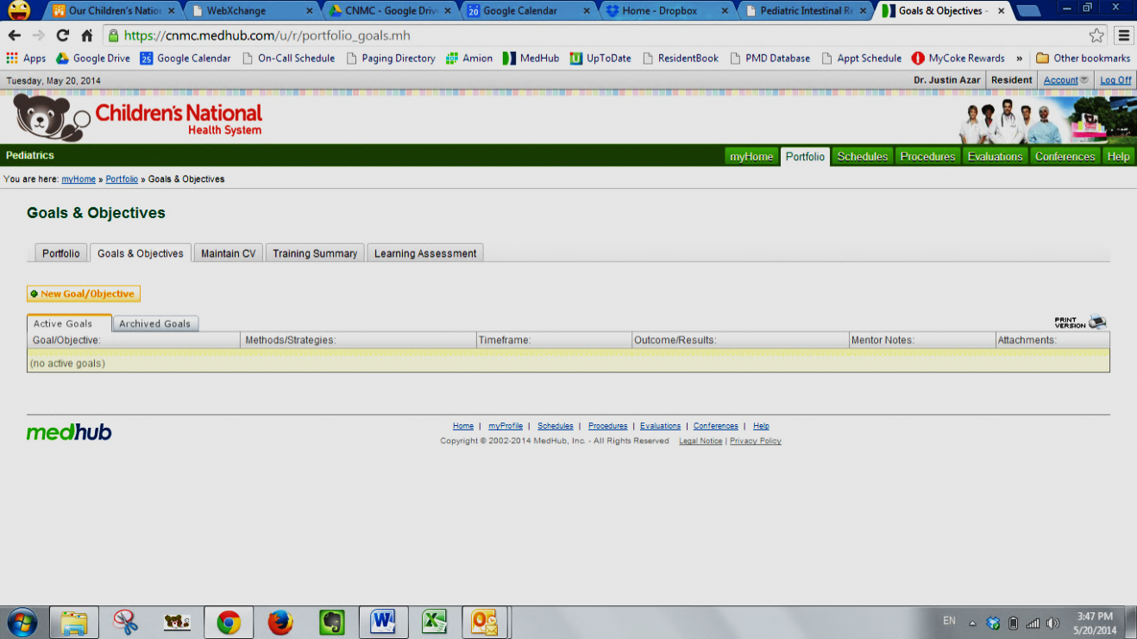

Step 4

Step 3

Step 2

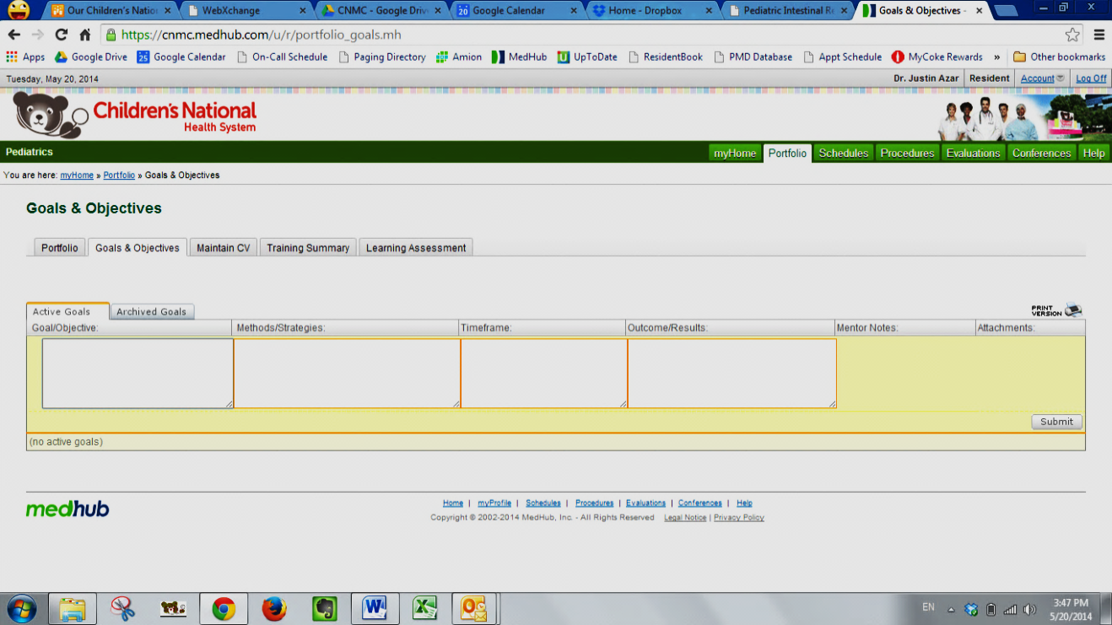

Step 5

**ILP Example of a completed Goals & Objectives entry on MedHub**