- Run Visits per Provider Per Day for Selected Time Period.
- Export results to an Excel Spreadsheet
- Label columns appropriately
- Delete out non-continuity clinic or non-credited days
- Divide daily totals by 2 for session analysis average

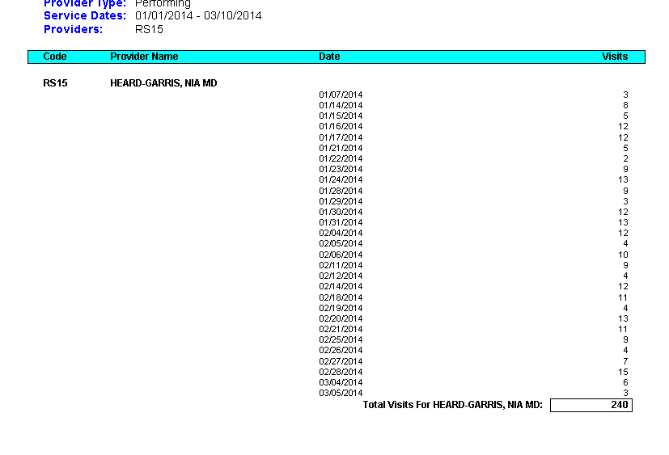

Add mock excel spreadsheet.

You must upload your experience log as well, please format in Excel spreadsheet so that you and your mentor can reflect on your experience.

