There are 4 total modules for the home visitation curriculum.

They are too big to upload to ResidentBook directly, so you can access 3 of them (Home Visitation 101, Sociocultural Determinants of Obesity, and Nutrition 101) via a DropBox folder here:
https://www.dropbox.com/sh/hc8keeplo1qihjp/AAAOPrBYZmzcO8qndF0prMija

Please review Home Visitation 101 first, before the other modules. The suggested order for the other modules is Sociocultural Determinants of Obesity, then Nutrition 101, and finally Motivational Interviewing.

The Motivational Interviewing Module comes from The American Academy of Pediatrics and can be accessed at: http://ihcw.aap.org/resources/Pages/default.aspx

You want to click on “Change Talk” which is at the top of the page and the program we want you to run though:
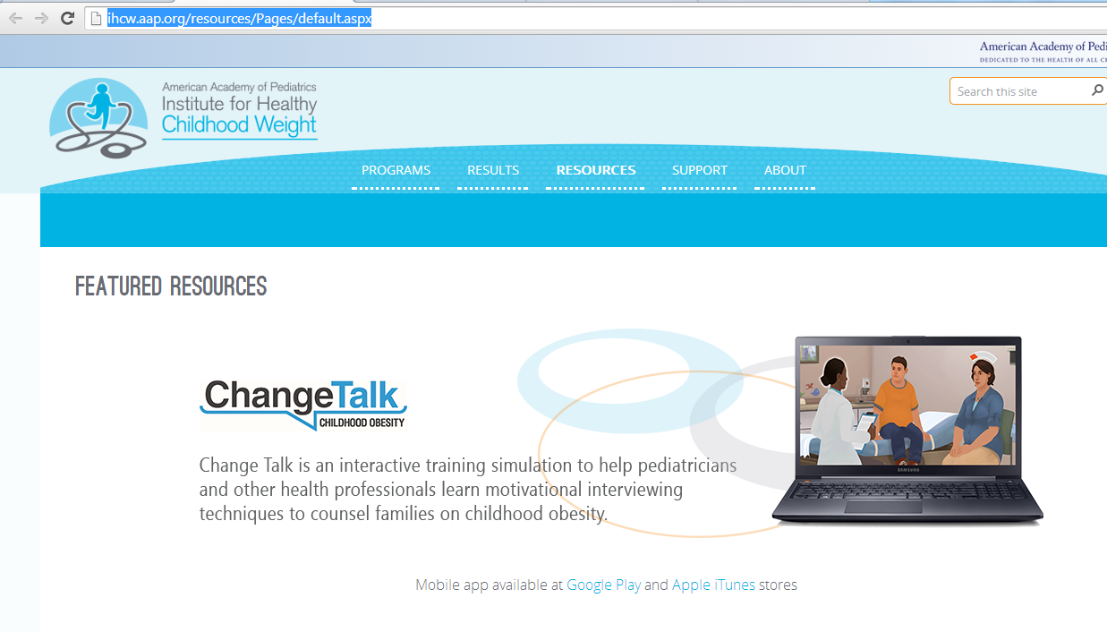

Be forewarned that is does take a few minutes to load and if you do not have Unity Player, you will have to follow the steps to download the program to your computer. On the other hand, it is apparently available as a mobile app, which hopefully will enhance accessibility.

