CNMC NICU

Rotation Structure | Contact Information
5-6 residents/rotation: 4-5 residents on days, 1 resident at night | Fellow: x8743, x7933, x 8655
NNP Team: Covers 4 pts on the weekends for the resident who has their golden wknd | Residents: x7934, x7936, x8870
Resident cap: 9-12 patients/resident | Dietician Victoria, Rebecca
Pre-round from 5:30/6am-8am | Case Magmt: Kim-x2725, Clydette 4332, and Pam
Radiology rounds 8-8:30am | BAERs: x5678
Lecture 8:30-9am | ROP: p1846
 | TPN: x8808

General Tips
- Equipment: No stethoscope needed! All the babies have their own! No white coats in NICU.
- Admission Exam: All new admissions need a complete exam. See below for the most commonly needed admission orders. NICU admission order set has all of the necessary orders
- Daily Exam: All babies should have a focused exam every day –attempt to examine your babies between 7:30-8:00am. Some infants in our NICU are very sensitive to touch or exam, so please do not be offended if you are asked NOT to examine the baby. Be sure to talk to your nurse about when they are going to do dressing changes, etc. so that you have the best opportunity to examine your patients.
- Med Reporting: Report all meds in mg/kg/dose or mg/kg/day.
- Daily Work: NICU is obviously not a very high turnover service. After rounds, make sure that your orders are up to date, notes are up to date, and TPNs are completed (nutritionists are on rounds to help with this). Hospital summaries and progress notes can become lengthy with all the information about the baby. Make sure not to use words like “yesterday” or “tomorrow.” Rather, insert the date that a medication was started or discontinued so as to not cause confusion for someone else looking at your note.
- Avoiding Random Phone Calls: Introduce yourself by name, number, and pager on rounds daily! Ask for your nurses names as well for best communication. Make sure you ask what orders need to be cleaned. There are lots of miscellaneous orders that become overwhelming to everyone involved. Save yourself the extra phone calls after rounds by just simply asking or giving the nurse an order clean up index card.
- DISPO: Kim, Clydette and Pam (Case Management) or Allison, Lauren and Alexis (Social Worker) are great resources for appts, prescriptions, outpatient imaging, hearing exams, etc. They are present on rounds nearly every day, so take advantage of having such a great resource!
- Pre-Rounding in Cerner: Orders, Labs/Microbiology, MAR
  - I-view: Vital signs (Apneas, Bradys, Desats), ICU Ongoing Assessment (Respiratory settings), Clinician summary (Vent Settings), Pain (Pain Scores, WAT scores), Lines, Tubes, Drains (Good place to find your patient’s current access (or go examine them!)
  - Intake and Output: Total Fluids (cc) /kg; Break up intake to reflect TPN, IVFs, Feeds (how much PO vs. Enteral); UOP: cc/kg/hr; Ostomy Output: cc/kg; Can use the TPN calculator Excel Sheet on every computer in the NICU resident room to calculate calories
  - Important Things to Include By System
- ACCESS: must be included for all patients
- Weight: keep up to date with the most recent weight
- RESP: vent settings and the most recent blood gas, medications
- CVS: medications
- FEN: I/Os, TPN (D__, P__, IL__), Feeds--formula, calories/oz, volume/rate, how often, advance, goal (for example—Enfamil 20cal/oz 50 cc q 3 increasing by 5 cc q 6 to a goal of 65 cc q 3); medications
- HEME: last transfusion
- OPHTHO: last exam, the results, and when the next exam will be
- GENETICS: NMS (when it was and if it was normal/abnormal)
- ID: antibiotics (day of treatment and planned duration), most current blood/CSF/resp/urine cultures
- NEURO: most recent HUS/MRI result

Weekly Orders
- For All Admissions
  - Consent within 24 hours (Both general and blood consent
  - DC NMS
  - Vitamin K
  - Erythromycin Eye Drops
  - Hep B and HBIG by 12 hours of life if Mom’s status unknown/positive
  - BMP, Mg, Phos, Bilirubin at 12 HOL and 24 HOL
  - Protective isolation if < 1000 grams
  - MRSA (nares), Ceftaz (rectal), VRE (rectal) swabs ordered on all patients
  - Glucose q 4-6 hours, then PRN
  - Follow up Mom’s prenatal labs (GBS, HIV, Hep B, RPR )
  - All babies should have respiratory care plan so that RT can wean vent as tolerated
  - Consent for donor breast milk if less than 1500g or 28 weeks
- Every Monday
- MRSA nare and Ceftaz rectal swab screens unless previously positive
- Update Med Calc Weight (this should be discussed on rounds especially if the weight is an estimation or the baby is edematous, etc. )
- Adjust meds per current med calc weight
- Order CXR for central line check on Tuesdays
- Every Wednesday
- Order CBC, BMP, Mg, Phos (TPN small set) for Thursdays
- Every Friday
- Order CBC, CMP, Mg, Phos, Triglycerides (TPN large set) for Mondays
- Order all XRs for weekend (order XRs for 5am)
- Routine Orders
- Routine weights are MWF
- Must have PIV for blood products unless patient has a broviac
- Eye exam at 32 weeks corrected age then PRN per Ophtho
- Head Ultrasound if less than 28wks gestation, on DOL 3 , 7 and 14
- Normal immunization schedule except no live vaccines in NICU
- Synagis per guidelines if not in isolette (15 mg/kg/dose)
- Radiology
- CXR every day for intubated ordered for next at 0500
- All other XRs ordered as STAT
- Order XRs on Mondays for Tuesday central line check
- Prior to Discharge
- Make sure Hep B when > 2000 grams
- Hearing Screen/BAERs
- Car Seat Test
- Congenital Heart Disease screen
- Discharge MRI if micropremie (less than 28 weeks)
- Circumcision (inpatient vs. outpatient)
- Prescriptions filled
- PMD and Subspecialty Follow Up
- Fax discharge summary to PMD

History and Physicals – the things we want to hear about!
- Maternal History
  - GBS (treated?!), HIV, Hep B, RPR, Rubella
  - Gestational DM, PIH (Magnesium?), other pregnancy complications
- Delivery: Vaginal vs. C-section, Resuscitation after birth, Apgars
- Birth Measurements
- Standard Interventions thus far: Vitamin K given? NMS sent? Hep B given? Hearing Screen done?
- History of urination and stooling?
- NICU Course at OSH: Include blood cultures and other labs pending

Intraventricular Hemorrhage
- Grade I: subependymal hemorrhage only
- Grade II: subependymal hemorrhage + intraventricular hemorrhage (filling < 50% of lateral ventricle)
- Grade III: IVH + ventriculomegaly
- Grade IV: parenchymal hemorrhage with or without IVH and ventriculomegaly
- Head US: All babies < 1500 grams should receive at least 3 head ultrasounds, at DOL 3, 7, DOL 14, and 6 weeks of age or prior to discharge
- MRI for all babies less than 28weeks prior to discharge

FEN
- Calculating Calories: From the FEN information you can calculate total daily fluids and calories and cc/kg and cal/kg.
  - Parenteral: TPN calculator in excel sheet can help you calculate how many parenteral calories your baby is receiving.
  - Enteral: When calculating how many calories the formula gave your baby, just divide the volume (cc’s taken) by 30 cc/oz and multiple by the formula concentration (22 cal/oz) which gives you total calories. Then divide this number by the weight to get cal/kg/day.
Total Fluid Goals (in cc/kg/day)
Gestation | Day of Life
 | 0 | 1 | 2 | 3 | 4
36+ weeks | 60 * | 80 | 100 | 120 | 140
32-36 weeks | 80 | 100 | 120 | 140
28-32 weeks | 100 | 120 | 140
25-28 weeks | 120 | 140
< 25 weeks | 140
- Formula Choice
- < 1500 grams: Enfamil Premature 24 cal/oz
- 1500-1800 grams: Enfamil Premature 24 cal/oz
- 1800-2200 grams: Enfacare 22 cal/oz
- Term Infants: Enfamil 20 cal/oz
- Advancing Feeds- See feeding protocol
- Trophic Feeds: provide 10-20 cc/kg/day x 4-7 days
- Advance feeds by ~ 20 cc/kg/day
- Can d/c TPN and hang D10 when feeds are ~ 100-110 cc/kg
- Growth Expectations
- < 2 kg: 10-15 gm/kg/day
- > 2 kg: 20-30 gm/kg/day

Respiratory Care Plans
Please Use the Following Guidelines when placing a Vent order. Every patient on a vent (SIMV, CPAP, NIPPV, HFOV) requires a vent order with an associated Care plan.

 | pH | pCO2 | Goal Sats
Pre-Term Infant with RDS | 7.25-7.35 | <7d: 40-50  >7d: 40-60 | 89-93%  (until retinal vascularization complete)
Premie with CLD | 7.25-7.35 | 50-70 | 89-93%  (until retinal vascularization complete)
Normal | 7.35-7.45 | 40-50 | >93%
PPHN/MA | Please consult fellow for management of vent settings for these patients.

Immunizations
- NO live virus vaccines are given in the NICU!
- DTap, Hflu, PCV, IPV can be given to all infants at 2 mo chronological age
- If Mom is Hep B +, all infants admitted during the 1st week of life, regardless of BW or gestational age, will be given BOTH HBIG and Hep B vaccine before 12 hours of age or ASAP.
- If Mom’s Hep B status is unknown:
  - Term or Preterm > 2000 gm: Give Hep B vaccine ASAP before 12 hours of life; Request that Mom be tested and if the mother is HBsAg +, give HBIG ASAP, but within 7 days
  - Preterm < 2000 gm:Hep B vaccine and HBIG within 12 hours of birth.
    - If Mom’s Hep B status is negative:
  - For term infants or preterm infants with BW > 2 kg and born to HBsAg negative women, start vaccinations at birth.
  - For preterm infants weighing < 2 kg and born to HBsAg negative women: Vaccination #1 at 30 days of age; however preterm infants who begin Hep B vaccination at < 30 days of age will require a 4th dose

Therapeutic Hypothermia (Cooling Patient)
- Criteria for Infants Eligible for Cooling – see checklist for cooling
  - > 36 weeks completed gestation
  - Must arrive for treatment within 6 hours of birth
  - Premature neonates are excluded (hypothermia is associated with increased mortality)
  - Evidence of hypoxic ischemic insult: Requirement for resuscitation at delivery, Moderate to severe encephalopathy
- Hypothermia: Placed on water filled cooling mattress to reduce body temperature to 92 degrees x 3 days; Re-warmed after 3 days of cooling
- Post Cooling
  - Asphyxiated infants are at risk of NEC from transient intestinal ischemia
  - Most infant recover oromotor function by the time of discharge
  - MRI should be performed between 7-10 days of life

Persistent Pulmonary HTN
- Mechanism: Increased pulmonary vascular resistance post-delivery leads to continuation of fetal RL shunts (foramen ovale & ductus arteriosus)
- Duration: Most infants resolve their PPHN by 5 days of age
- Treatment Protocol: Keep Hct > 40; Keep MAPs normal/slightly elevated (you don’t want to increase the right to left shunt!); Treat Hypotension in PPHN with 10 cc/kg NS, PRBCs, and Dopamine
- Respiratory Management: You want patient to be slightly alkalinized to induce Hyperventilation. Please consult with your fellow for exact settings.
      - When to Consider ECMO: After maximal therapy has been achieved and Pa02 < 50 x 2-3 hours, patient should be considered for ECMO
      - ECMO Criteria: > 2 kg, < 10-14 days of assisted ventilation, Reversible lung disease, No severe IVH (> Grade II), Failure of max medical management

Rule out Sepsis
      - All babies should have a complete sepsis work up including CXR, blood, urine, and CSF
      - Medication Levels
        - Vanc: obtain trough before the 3rd dose
        - Gent: obtain peak after the 2nd dose and trough before the 3rd dose

Neonatal Advanced Life Support
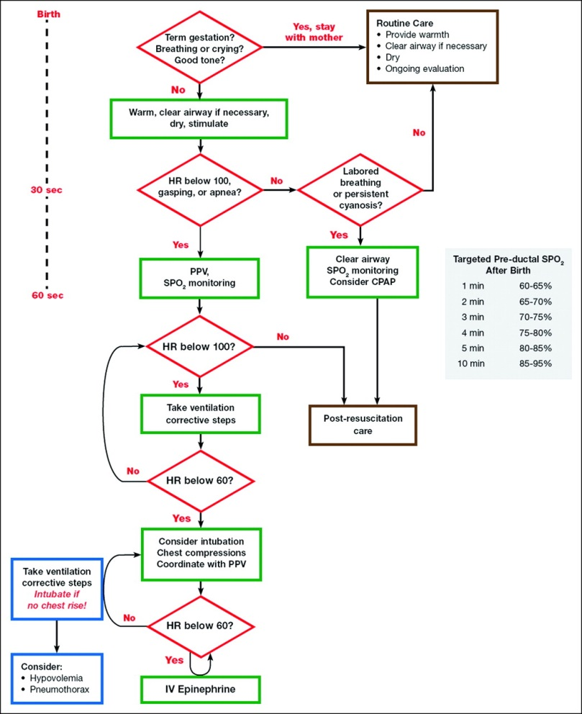

Endotracheal Intubation
Gestational Age (weeks) | Weight (kg) | ETT Size (mm) | Insertion (cm from upper lip)
< 28 | < 1.0 | 2.5 | 6-7
28-34 | 1.0-2.0 | 3 | 7-8
34-38 | 2.0-3.0 | 3.5 | 8-9
> 38 | > 3.0 | 3.5 -4.0 | 9-10
Depth of insertion (cm) = 6 + weight (in kg)

- Epinephrine: 1:10,000 concentration, Use 0.01-0.03 mg/kg (0.1-0.3 mL/kg) ET or IV. Give rapidly, flush catheter/ETT with 0.5-1 mL NS.
- Normal Saline: 10 mL/kg IV or UVC over 5-10 minutes to volume expand
- Sodium Bicarbonate: 0.5 mEq/mL (4.2% solution), Use 1-2 mEq/kg (2-4 mL/kg), administer slowly over at least 2 min and only if newborn is being effectively ventilated
- Naloxone: 0.1 mg/kg rapid IV or ET (can give SQ or IM too) for narcotic induced respiratory depression- if mom is on drugs, baby may seize due to withdrawal so need maternal history prior to giving it.
- Glucose: For hypoglycemia give D10W 2 mg/kg IV over 1-2 min followed by continuous glucose infustion
- Phenobarbital: 20 mg/kg slowly IV (1 mg/kg/min) for seizures although recognize it may depress respiratory effort
- Dopamine: 2-20 mcg/kg/min via continuous IV for hypotension

Umbilical Lines
- High Umbilical Artery Catheter (UAC)
  - Location: Tip between T6 and T9 in order to pass the celiac artery (T11), superior mesenteric artery (T11-T12), but not as high as the aortic arch and subclavian arteries (T5)
  - UAC length (in cm) = [3 * Birth weight (in kg)] + 9
  - Malpositions and what to do:
    - If catheter is higher than T6: Pull it back until it is between T6 and T9, repeat CXR to verify correct position
    - If catheter is curved back on itself, Try to pull back on the catheter to see if it will straighten out. Repeat the AXR after the catheter has been repositioned. If the catheter is still curved upon itself further attempts to reposition will most likely be unsuccessful therefore it should be removed and a new sterile catheter inserted.
    - If catheter is below T9, pull it back until it is at the level of L3 to L4 (i.e. convert the catheter from a high to a low line)
- Umbilical Venous Catheter (UVC)
  - Location: Tip between IVC and RA
  - UVC length (in cm) = [0.5 * High UAC length] + 1

- Low Umbilical Artery Catheter (UAC)- Not recommended
  - Location: Tip between L3 and L4 to avoid injuring the renal (L1) and inferior mesenteric (L2) arteries but above the bifurcation of the aortic and iliac arteries around L4/L5
  - UAC length (in cm) = Birth weight (in kg) + 7
  - Malpositions and what to do:
    - If catheter is between L2 and T10: Catheter needs to be repositioned to a low line at L3 and L4. Once the catheter has been repositioned, repeat an AXR to check the new catheter placement.
    - If catheter is curved back on itself: Try to pull back on the catheter to see if it will straighten out. Repeat the AXR after the catheter has been repositioned. If the catheter is still curved upon itself further attempts to reposition will most likely be unsuccessful therefore it should be removed and a new sterile catheter inserted.
    - If catheter is down the leg: Remove it and replace with a new sterile catheter
    - If catheter is too low (below L4): It may be in an iliac artery in the leg. Do not push it in! Once a sterile field has been disassembled a catheter should not be advanced. Remove the catheter and reinsert a new one using sterile technique.

- PICC lines :
  - Are placed by PICC team (Fellows/attendings and transport nurses)
  - Should be removed by PICC team only
  - Dressing changes are also performed by PICC team

