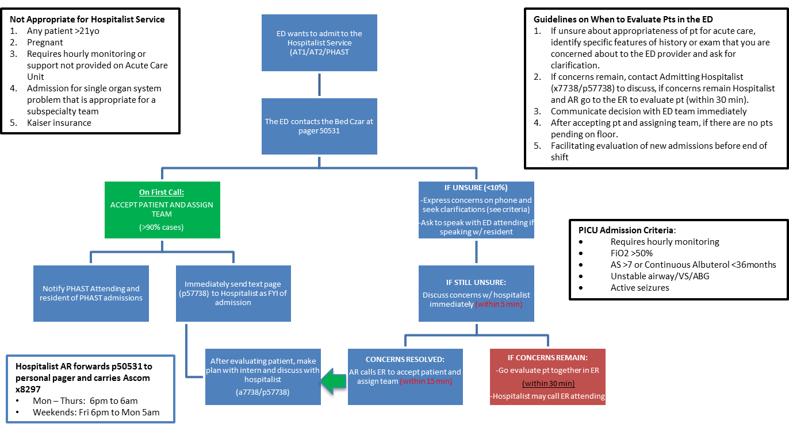

**Daily Checklist**

|  |  |
| --- | --- |
| **Start of Shift** | **End of Shift** |
| * Forward HAR pager (p0531) to personal pager & un-forward Ascom | * 6am handoff with PHAST MD to ensure all admits accounted for and debrief the night |
| * Receive sign out on pending admits from daytime seniors | * Discuss lingering questions, systems issues, safety concerns |
| * 6pm huddle in Doc Box with Bed Czar, PHAST Doc & other AT PL-2 | * Forward HAR phone to Bed Czar phone & remind Bed Czar to forward HAR pager |
| * Determine team caps & current census |  |
| * If > 3 admits, divide up work with attending/fellow AT residents | ***\*Handoff to PHAST MD at 6am: No new H&Ps to be started after 530a; Ensure all pending pts are appropriate for floor; if on floor, do admit orders then sign out to***  ***PHAST at 6a to complete the admit*** |
| * Determine plan for subsequent admission assignments |

**High Census – AT4 Activation Protocol** *(*1 conditional discharge does not count toward total census)*:

* When 14 pts on Red and 24 combined on AT2:
  + Place pts on Silver if space available (Max of 4). Kaiser and Endocrine patients are still prioritized to Silver
  + If Silver capped, place pts on AT4
* All pts admitted to AT4 should be prioritized to 4Main or 5East (notify Bed Control AT4 is activated)
* Work with PHAST MD to safely admit or transfer pts to AT4 care team
  + Low acuity, low complexity, short LOS pts prioritized to AT4
  + Complex patients should preferentially be admitted to ATs to enhance continuity of care
  + Metabolic pts MUST go to AT2-Orange
  + Ensure admit/transfer orders in Beartracks reflect appropriate care team (AT4)
  + Pts transferred to AT4 do not require a hospital summary if LOS <48hrs
  + PHAST MD to sign-out all AT4 pts to daytime Bed Czar in AM

*Full Protocol: ResidentBook Home>> Rotations>> Inpatient>> Nights, Wkends, Holidays>> HAR>> High Census Plan*

**PICU Admission Criteria**:

* Requires hourly monitoring
* FiO2 >50%
* AS >7 or Continuous Albuterol <36months
* Unstable airway/VS/ABG
* Active seizures

**HOSPITALIST ADMITTING RESIDENT QUICK REFERENCE SHEET**

**PHAST Admission Criteria**: *\* Length of Stay is NOT an exclusion criteria*

* Narrow differential diagnosis
* Generally healthy patient without complicated PMH
* No family/patient situation requiring continuity of care (i.e. NAT, neglect concerns)
* Less than 3 consulting services

Examples of acceptable diagnoses:

* Bronchiolitis (oxygen requirement OK)
* Asthma (Continuous Albuterol OK)
* Complete Kawasaki Disease
* Neonatal fever
* Neonatal jaundice
* Osteomyelitis
* Meningitis

Examples of unacceptable diagnoses:

* BRUE
* FUO
* Chronic Abd pain
* Failure to Thrive
* Incomplete Kawasaki Disease
* No clear/definitive diagnosis

When in doubt whether a patient is appropriate for PHAST, **assign to PHAST**, **then call** the PHAST attending to confirm.

**HAR Admission Algorithm**