

**Media Policy**

Recently, there have been questions regarding Children's Media Policy. As a reminder, the policy is below for your review. Please note that all media interaction (whether its calls, interviews or article submissions) must be coordinated through the Public Relations and Marketing Department.

**Requests for Interviews:**

Interviews with Employees - It is the general policy of Children's National Medical Center (CNMC) to cooperate with the news media and to provide information and experts as quickly and accurately as possible within the bounds of patient confidentiality. Such requests for information about patients or hospital activities should be directed to the Public Relations and Marketing Department.

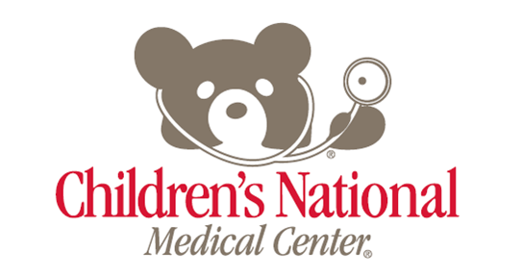Any interview with a physician or employee representing CNMC must be coordinated through the Public Relations Department before any arrangements are made. Public Relations and Marketing wants to ensure that our media efforts are coordinated, that interviews do not compromise or conflict with any other CNMC issues or efforts, and that we are being consistent with the media policy of the hospital. This includes interviews with social media and online outlets.

Please have the reporter call Public Relations and Marketing at x4500 when you receive an interview request, prior to consenting to do the interview. The Public Relations staff will arrange the interview and accompany the press representative to the location of the interview if on hospital grounds.

**Interviews with Staff in the event of a trauma:**

Doctors may not speak on a particular patient without the consent of the family and Public Relations.

Family's Desire to Address Media/ Cases Generating Large Media Interest

In cases that generate significant media interest in which the family wants to speak to the media, Public Relations may accommodate these requests on campus. It is up to the Public Relations Manager and/or Public Relations Director, to determine when this is appropriate. In some cases a media briefing may be conducted. This is done only at the discretion of the Vice President and Chief Government and External Affairs Officer.

**Camera crews on Hospital property:**

TV crews and reporters ARE NOT ALLOWED in the hospital at any time without the express permission and knowledge of the Department of Public Relations. A public relations staff member will accompany TV news crews, photographers and reporters at all times. The grounds outside the hospital are public domain and crews can shoot there. The arrival of ambulances and transfer of a patient to the ER may be photographed from this location.