Appendix A. Good Clinical Practice (GCP) Vignette – Informed Consent and Assent of Research Participants in Clinical Trials Involving Drugs, Biologics, and Devices

1. Users can select the GCP vignette player from a variety of courses available on the CTSI-CN portal, FACTS (http://www.childrensmedicaleducation.org/research/).
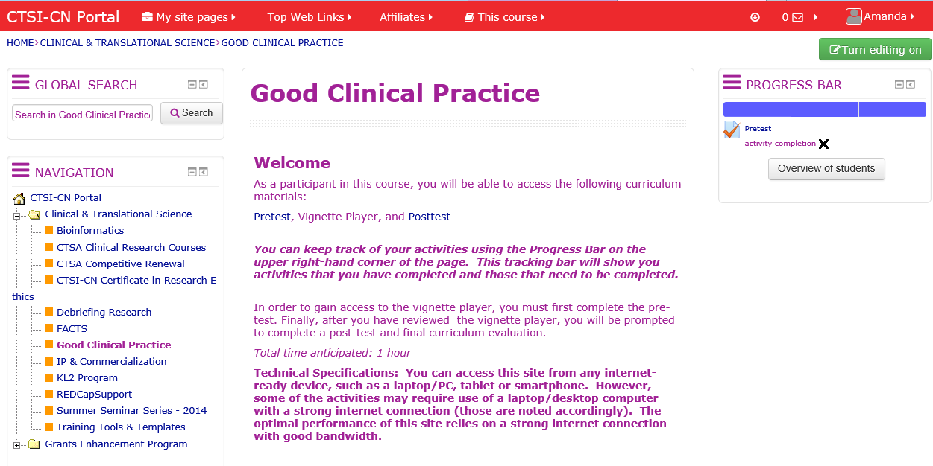

2. Once a user has selected the GCP course, they are directed to the course homepage where they will begin their GCP experience completing the pretest.
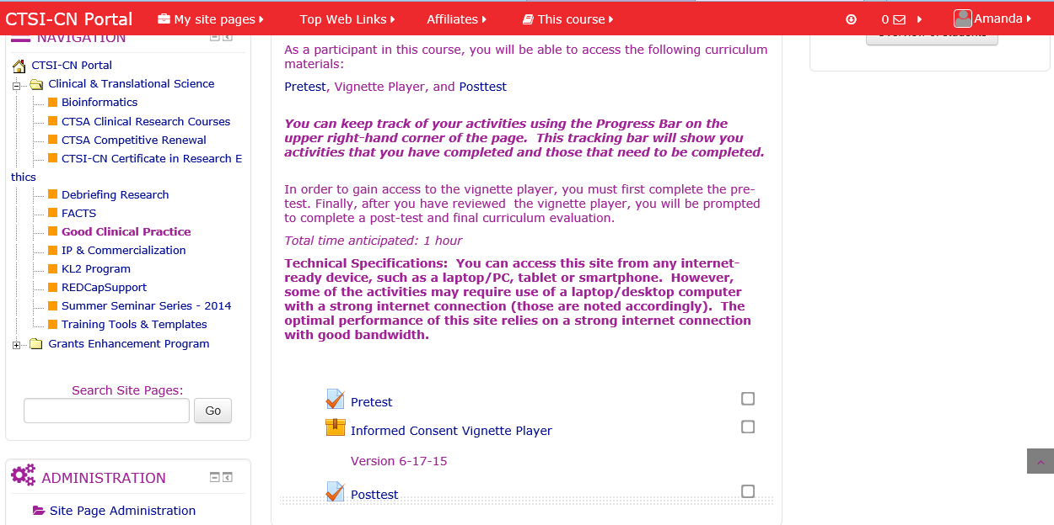

3. There are over 100 external plugins are integrated into the FACTS portal including virtual conferencing, game and quiz makers, and more.
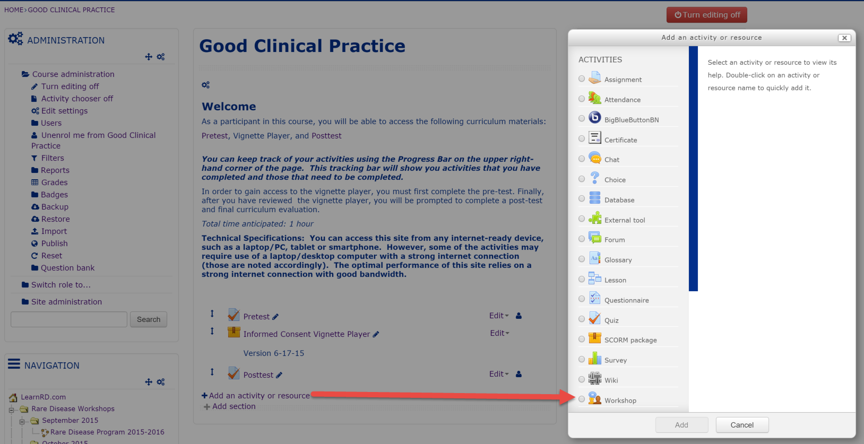
4. Within the pretest, existing knowledge of International Conference on Harmonization (ICH) GCP training including: GCP Overview, the Principles of ICH GCP and Investigator responsibilities, as they pertain to informed consent/assent, are assessed. Immediate feedback is given upon completion.
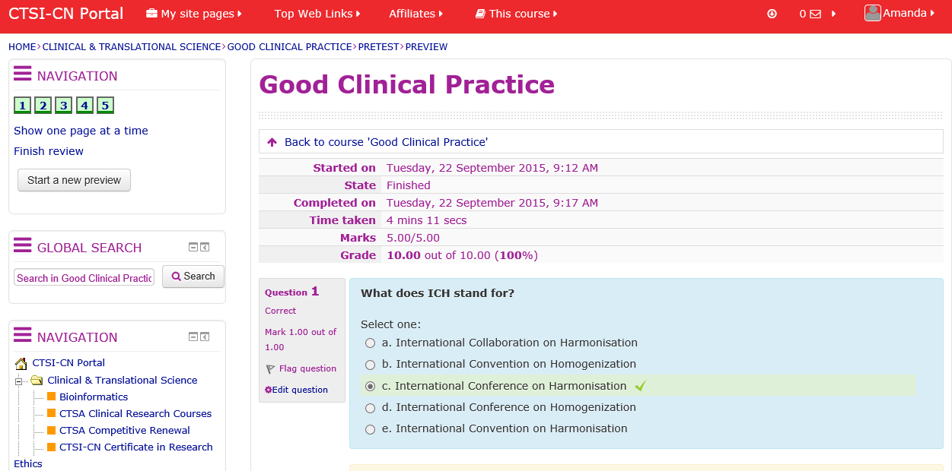

5. Once users launch the GCP vignette, they are taken to the home page of the player where they will initiate the course.
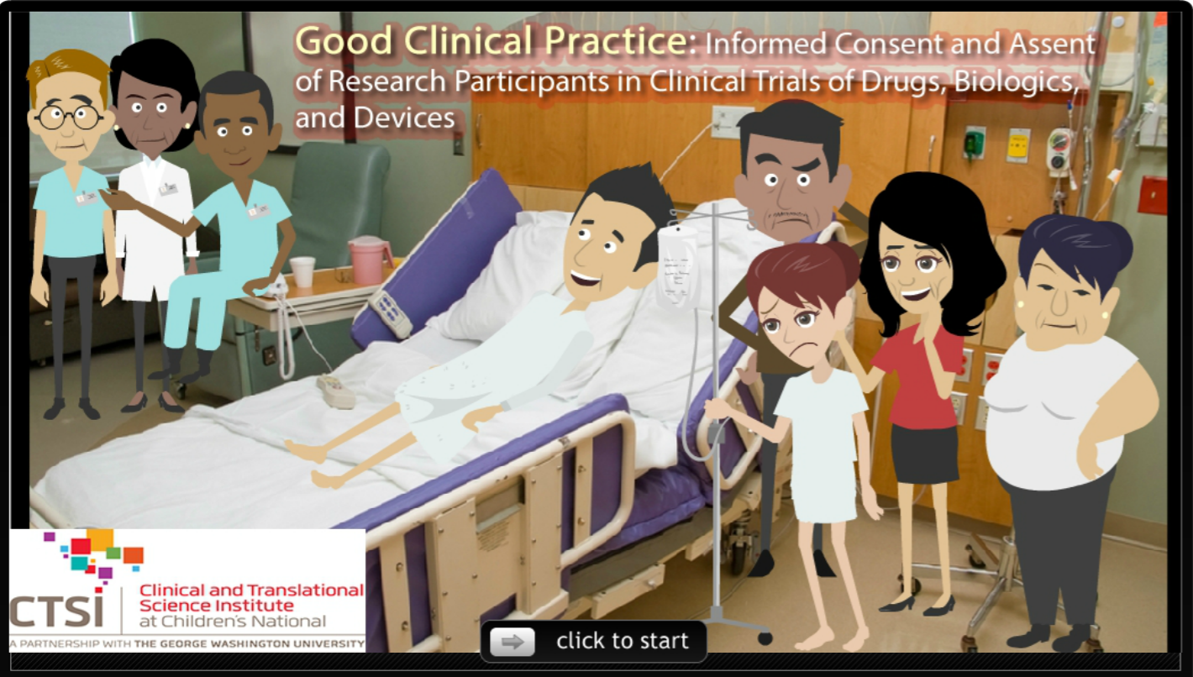

6. Knowledge checks are performed throughout the various scenes of the vignette player.
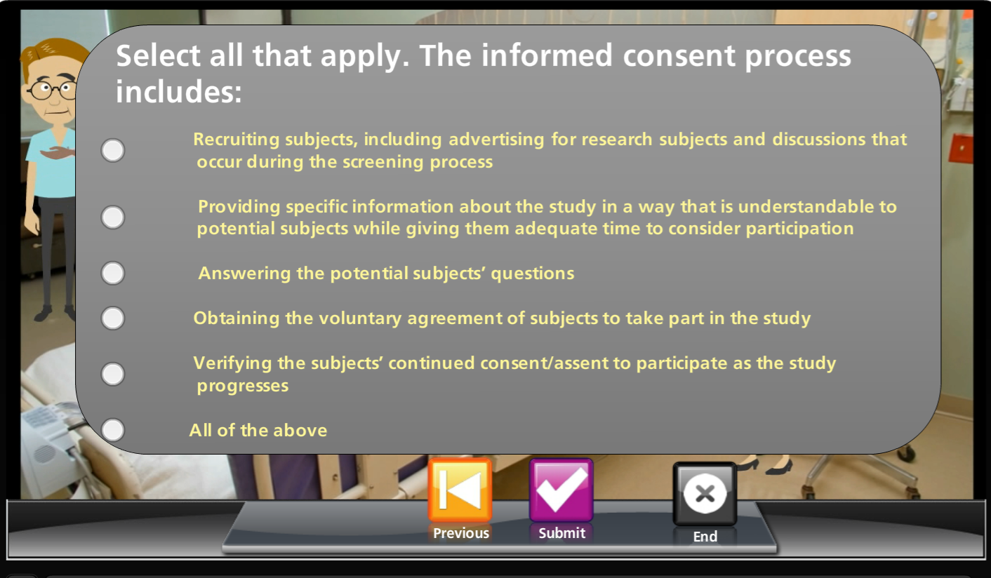

7. Immediate feedback is given based on the selected response.
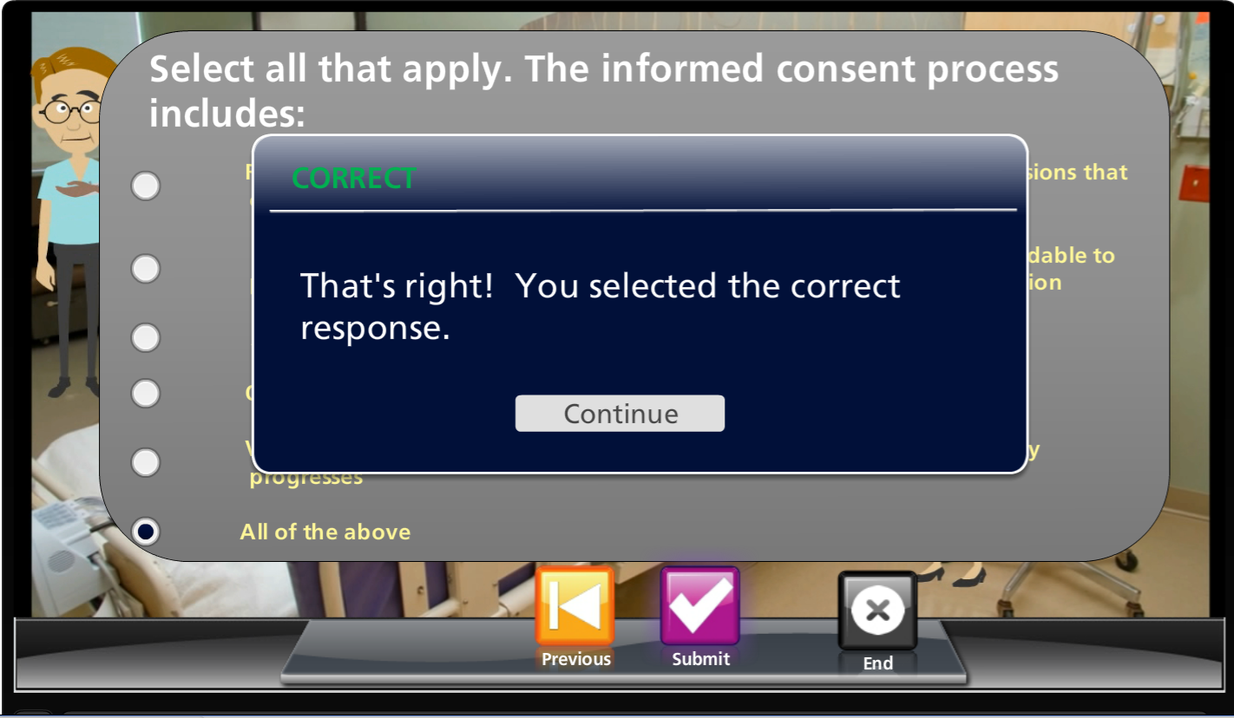

8. Finally, a post assessment is given at the completion of the vignette player. The user is given further information about where in the ICH document the concept is further explained.
