Community Health Track Mentor List: Please feel free to contact any of the below folks with any questions-including but not limited to complementing your inpatient experiences with community work, planning your community health track building blocks, and planning for your future career.

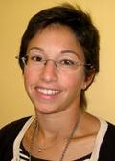
Cara Lichtenstein, MD
Dr. Lichtenstein is the Program Director of the Community Health Track. In addition, she works 2 days a week at the Children’s Health Center at MLK in SE, and also at the Children’s Health Center at CNMC. During her Pediatric Residency at Montefiore Medical Center, she became interested in doing community health work through home visits that taught her that there was more that influenced health than just biology. She solidified her interest in Community Pediatrics during her Fellowship in General Academic Pediatrics at CNMC. Her biggest area of interest is in sociocultural determinants of health and specifically how to educate learners about them. She is also a member of the AAP’s Council on Community Pediatrics and is part of the Academic Pediatric Association Taskforce on Childhood Poverty, working on creating a curriculum for residents on Childhood Poverty.

Marceé White, MD
Dr. White is currently the Medical Director of the Children’s National Health System Mobile Health Program and the Children’s Health Center at THEARC. She also serves as the Assistant Director of the Community Health Track. Dr. White earned her Medical Degree from George Washington University School of Medicine and completed her pediatric residency training from the combined Children’s National and Howard University Community Health Track. She then stayed on for a year as a chief resident, before joining the Children’s Health Project of DC in 2008. Dr. White is passionate about educating medical trainees to address the social determinants of health and inspiring them to serve communities in need. She serves on the Board of DC Action for Children and the DC Chapter of the American Academy of Pediatrics. She is also a member of the DC Pediatric Oral Health Coalition.

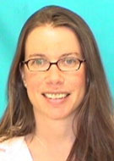
Melanie Anspacher, MD
Melanie Anspacher is an attending physician in the Hospitalist Medicine Division and also works with the PANDA palliative care team. She founded and is co-director of the Global Child Health Curriculum at CNMC. Prior to coming to CNMC, she lived in Vientiane, Laos where she served as the Pediatric Residency Coordinator with Health Frontiers, a non-profit organization that supports post-graduate training for Lao physicians. She continues to serve this organization as a board member, and as the volunteer coordinator for the site. During medical school and residency, she completed did international health work in El Salvador and Honduras. These experiences have influenced her interest in working with and advocating for vulnerable, underserved populations, particularly in developing countries and immigrant populations. She is very interested in global health and immigrant health education for pediatric residents.

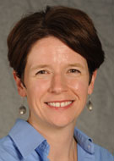
Lee Ann Savio Beers, MD
Dr. Beers is the Medical Director for Municipal and Regional Affairs within Children’s National’s Child Health Advocacy Institute (CHAI) and also the past Director of the Healthy Generations Program, a multi-disciplinary program for adolescent parents and their children at the Goldberg Center. She also directs the DC Collaborative for Mental Health in Pediatric Primary Care. She earned her medical degree from Emory University School of Medicine and completed a Pediatric Residency at the Naval Medical Center in Portsmouth, VA. Dr. Beers has held various leadership positions in the American Academy of Pediatrics (AAP) and is the Immediate Past President of the AAP DC Chapter. She co-chairs the Mayor’s State Early Childhood Development Coordinating Council. Her clinical and research interests include adolescent pregnancy and parenting, child abuse and neglect prevention, mental health care, and advocacy education.

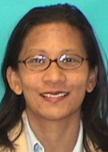
Kathy Ferrer, MD
Dr. Ferrer is a co-director of the Special Immunology Services Clinic at Children’s National Medical Center, which serves perinatally-HIV infected populations. She is also a Pediatric Hospitalist and she co-coordinates the Global Health Course at CNMC. Dr. Ferrer completed medical school at Robert Wood Johnson Medical School and Residency at the Baylor College of Medicine. She has always been interested in grassroots projects, working with underserved and vulnerable populations. She is particularly interested in Advocacy and International Health. Prior to working at CNMC, she worked as the Medical Director of the Lesotho Center of Excellence, in South Africa, with the Baylor Pediatric HIV Corps. She has also worked as a physician for the Indian Health Service in Chinle, Arizona. She also does work with the Clinton Health Access Initiative and the Peace Corps.

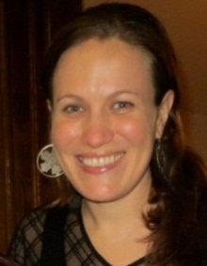
Aimee Grace, MD, MPH
Aimee Grace is a Fellow in General Academic Pediatrics at CNMC. Aimee went to Stanford University, majoring in Human Biology (focus on International Health and Policy) and medical school at the University of Hawai’i in her hometown of Honolulu, HI. She completed her residency in Pediatrics at Stanford University and her MPH degree (Health Policy and Management) at the Harvard School of Public Health. Aimee has pursued global health work from China to Peru to the Marshall Islands and more, and has led multiple grassroots advocacy efforts on topics such as HIV/AIDS, human trafficking, and community engagement. Her primary areas of interest are Medicaid and CHIP, pediatric benefits in the Affordable Care Act, Native Americans/Native Hawaiians, and community-based primary care. She is the co-founder of HEAL Trafficking (Health Professional Education, Advocacy, and Linkages.)

Sarah Guerrieri
Sarah is a Government Affairs Specialist at Children’s National Health System. She has a Master of Arts in Government and a Graduate Certificate in Nonprofit Management both from Johns Hopkins. She is also a part of the DC Collaborative for Mental Health in Pediatric Primary Care. She has worked for the Maryland Senate and the Committee on Energy and Commerce and the Senate Judiciary Committee on Capitol Hill. She became involved in resident advocacy education as a way to assist residents who were interested in legislative advocacy. She is also available to give background information on government affairs, and help define advocacy and provide details about the many ways in which doctors can also be advocates. One of the most important parts of her job is that she is able to stand up for kids, who are often forgotten in healthcare conversations. She finds it extremely rewarding to be a voice for them.

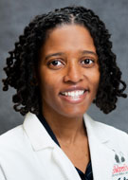
Sahira Long, MD
Dr. Long is the Medical Director of the Children’s Health Centers of SE (CHC Martin Luther King and Good Hope Road location). She attended the George Washington University School of Medicine and completed her residency as part of the Primary Care Track at CNMC. She left residency with a desire to bridge the gap by bringing the same level of high quality health care she was trained to provide to those who need it most, the medically underserved. She is interested in advocacy and community transformation with a focus on breastfeeding. She is particularly concerned with eliminating breastfeeding disparities among African Americans and other women of color. She has worked on several advocacy projects with the United States Breastfeeding Committee and has served as a panelist in the US Surgeon General's Call to Action to Support Breastfeeding (2011.) She also coordinates a Breastfeeding elective for Medical Students and Residents.

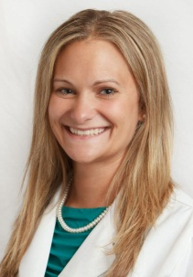
Abby Nerlinger, MD
Dr. Nerlinger is currently a Pediatric Hospitalist Medicine Fellow at CNMC. Dr. Nerlinger has worked in the Health Department at the Environmental Defense in Washington DC, the Superfund center at Duke’s University Nicholas School for the Environment, and Yale School of Medicine’s Department of Occupational and Environmental Medicine. In addition to her current position, she also works with the Mid-Atlantic Center for Children’s Health and Environment affiliated with CNMC. Dr. Nerlinger is specifically interested in how building healthy communities can affect hospital resource utilization. Her interest in healthy communities is focused around environmental triggers for disease including indoor/outdoor air pollution, healthy homes, and toxin exposure. She is also currently working on novel ways to include advocacy into the hospitalist inpatient rounds.

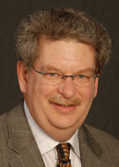
Jerome Paulson, MD
Dr. Paulson is the Medical Director for National & Global Affairs at the Child Health Advocacy Institute (CHAI) at CNMC and he directs the Mid-Atlantic Center for Children’s Health and the Environment (MACCHE.) MACCHE is one of 10 pediatric environmental health specialty units (PEHSUs) in the US. He has also spent over 30 years teaching and practicing primary care pediatrics. He has been involved in several advocacy and public policy projects including, gun violence prevention activities, development of a coalition in Ohio that lead to the passage of a mandatory seat-restraint law for children birth to five, and many more! His largest interest is environmental health and teaching health professionals about the role advocacy can play in one’s career. Dr. Paulson has served as members of both the AAP and the American Pediatric Association which have been essential to his career development and his ability to be a successful advocate.

Daniel Newman, MD
Dr. Newman works at the Children’s Health Center at Adams Morgan. It was his intention to work in community pediatrics when he started his path to a career in medicine. He realized before medical school that there was more to a child’s health than what goes on at the doctor’s office. Family life, school, and community support are far more crucial. He believes that if we want to make the greatest impact, it only makes sense that we collaborate and work together outside of the traditional "medical" world. His particular interest is in Immigrant Health. He has done international work in El Salvador, Peru, Guatemala, and Mexico. He realized that working with the immigrant populations here in the US was not always that different. He is also a member of the DC AAP Special Interest Group on Immigrant Health.

Heidi Schumacher, MD
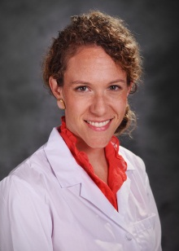
Dr. Schumacher is currently a Health Insurance Specialist at the Center for Medicare and Medicaid Innovation, where she works on bundled payment models. She is also a clinical associate at the Children’s Health Center at THEARC. She earned her Medical Degree at the University of Vermont College of Medicine and completed her pediatric residency and chief residency at CNMC in the Community Health Track. Throughout medical school and residency, Dr. Schumacher became increasingly interested in the intersection between clinical medicine and broader government, community, and family systems as they relate to health and wellness for children. Her interest in federal level health policy grew during residency, where she did work on topics ranging from funding for Graduate Medical Education to essential health benefits within the Affordable Care Act. She is passionate about sharing her love of advocacy and policy with other health professionals, and can be contacted at: Heidi.schumacher@gmail.com.

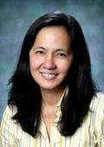
Nathalie Quion, MD
Dr. Quion is the Medical Director of CHC Northwest (Adams Morgan and Shaw) where she also works as a Primary Care Pediatrician. She completed medical school in the Philippines, pediatrics residency at the University of Texas, and a pediatrics fellowship at the University of Massachusetts. She became interested in working in community pediatrics during her residency training in Houston after doing an elective in a community health center. She is particularly interested in advocacy, global health, health literacy, immigrant health, and pediatric tuberculosis. She also started the DC AAP Immigrant Health Special Interest Group.

Kamillah Wood, MD, MPH
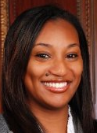
Dr. Wood works is the Associate Medical Director of the Mobile Health Program at the Children’s Health Project at THEARC. She completed her pediatrics residency at The Children’s Hospital of Philadelphia, where she stayed on as a chief resident. She then completed a fellowship in health policy and health disparities as a Commonwealth Fund Harvard University Fellow in Minority Health Policy. As a part of the fellowship, she obtained a Masters in Public Health at the Harvard University School of Public Health, with a concentration in Family and Community Health. During this time Dr. Wood conducted a practicum project with the Massachusetts Department of Public Health, Office of HIV/AIDS, where she evaluated HIV testing patterns in minorities after health care reform in Massachusetts. She also conducted an after school teen group at a local homeless shelter using innovative tools to provide health education to this vulnerable population.

