PL3 Roles:
PL3
- Supervise the residents as able for all teams, in addition to being the night time contact for your own personal team (either GI or PA). Remember that your colleagues on Heme/onc, cards, and ICU rotations might need your help as well.
- Get sign out on your team and the Watcher patients on the Academic Teams
- Attend CATS/Codes.
  - As part of these teams, it is appropriate to put in any orders necessary to help stabilize and ensure the safety of that patient's care.
- Complete PICU/NICU transfers to inpatient and staff with the Bed Czar/PHAST attending.
  - Please remember: You must staff all PICU transfers to Hospitalist Teams (except for Kaiser patients) with the in-house attending x7738. Please do this on a rolling basis so as not to "dump" several transfers on the attending at once.
- Complete Hospitalist consults and staff with the Bed Czar/PHAST attending.
- Help plan teaching sessions. Please make sure that you are teaching “core curriculum” three of those nights at minimum.

NIGHTS WITH TWO PL3S
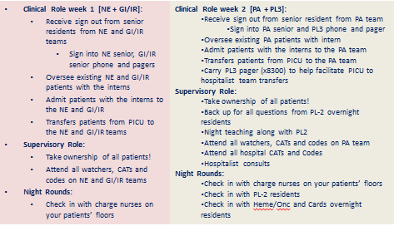

NIGHTS WITH TWO PL3S + CRENAL
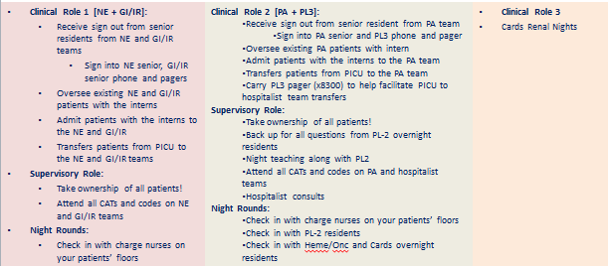

NIGHTS WITH THREE PL3S
